Grazioso Salvare README

About the Project
This project is designed to filter breeds of dogs from a database of animals from the Austin Animal Shelter and display graphs to help the user interpret the filtered information.

Motivation
This project exists so that the rescue-animal training company Gravioso Salvare can identify and categorize dogs that are appropriate for different types of training. Specifically, Gravioso Salvare wants to find dogs suited for Water Rescue, Mountain or Wilderness Rescue, and Disaster Rescue or Individual Tracking.

Getting Started
To get a local copy up and running, follow these steps:
- Import the Austin Animal Shelter data set in MongoDB by running
cd ./datasets
mongoimport --type=csv --headerline --db aac --collection animals --drop ./aac_shelter_outcomes.csv
- Create a new user account for the database by running
mongosh
use admin
db.createUser( { user: "aacuser", pwd: passwordPrompt(), roles: [ { role: "readWrite", db: "aac" } ] } )
- Run the ProjectTwoDashboard.ipynb file in Jupyter Lab
- Connect to the Dash dashboard using the link output by Jupyter Lab

Installation
You need an installation of Jupyter Lab to run the Python code:
https://jupyter.org/install
You need MongoDB to access the animal shelter database:
https://www.mongodb.com/try/download/community
PyMongo is used to work with MongoDB in Python:
https://pypi.org/project/pymongo/
Dash is used to build the web framework for the Python code:
https://dash.plotly.com/

Why MongoDB
MongoDB was used as the model component of the development because it is well-suited for working with and manipulating large databases. Paired with PyMongo, MongoDB is also able to be used with Python code that runs functions on the animal shelter database.
Why the Dash Framework
The Dash framework works with Python and MongoDB to build a web framework. Dash provides the view structure for the web application as it displays HTML components that show the entries in the database and graphs of the data. Along with this, Dash provides the controller structure for the web application as it allows the user to interact with it on the client level using things like radio buttons to manipulate the information that is displayed.

Functionality Screenshots
Starting state of the dashboard:
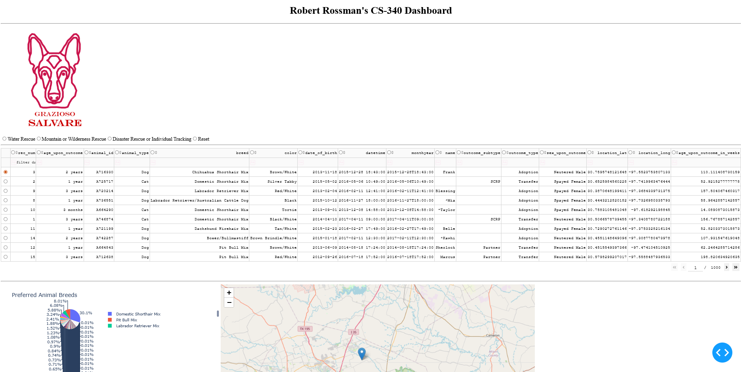
“Water Rescue” data filter applied:
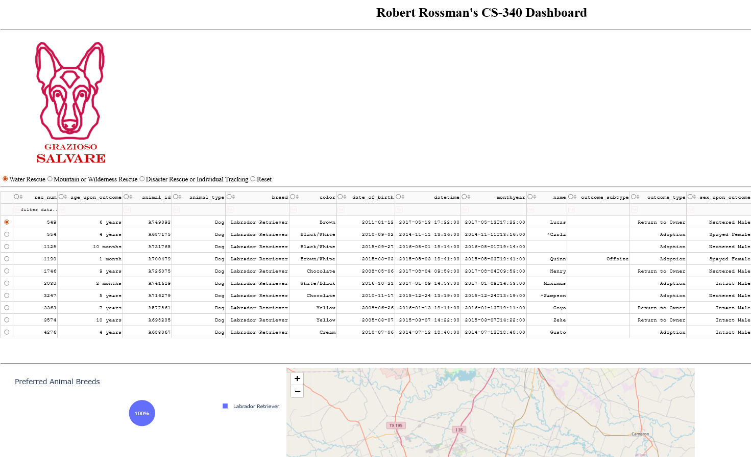

“Mountain or Wilderness Rescue” data filter applied:
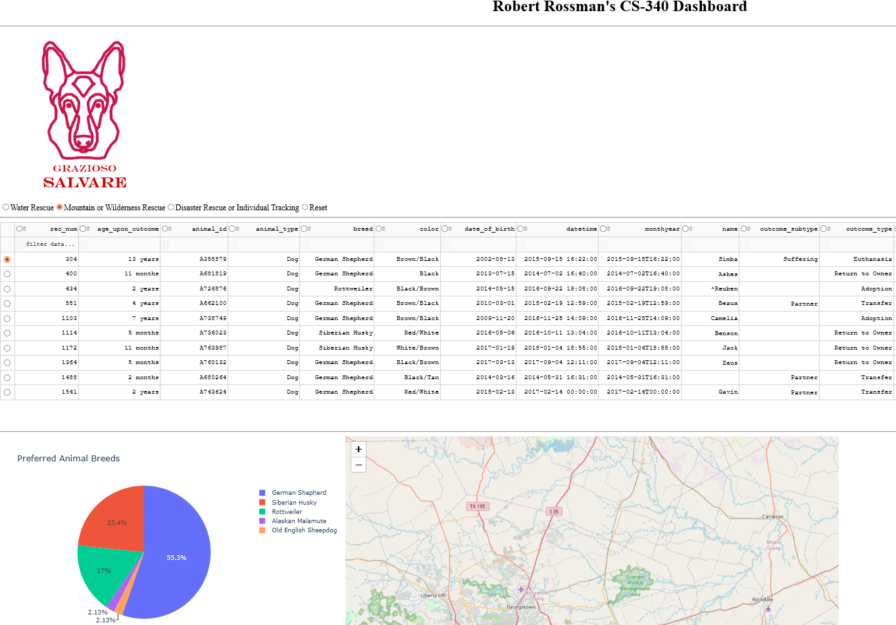
“Disaster Rescue or Individual Tracking” data filter applied: 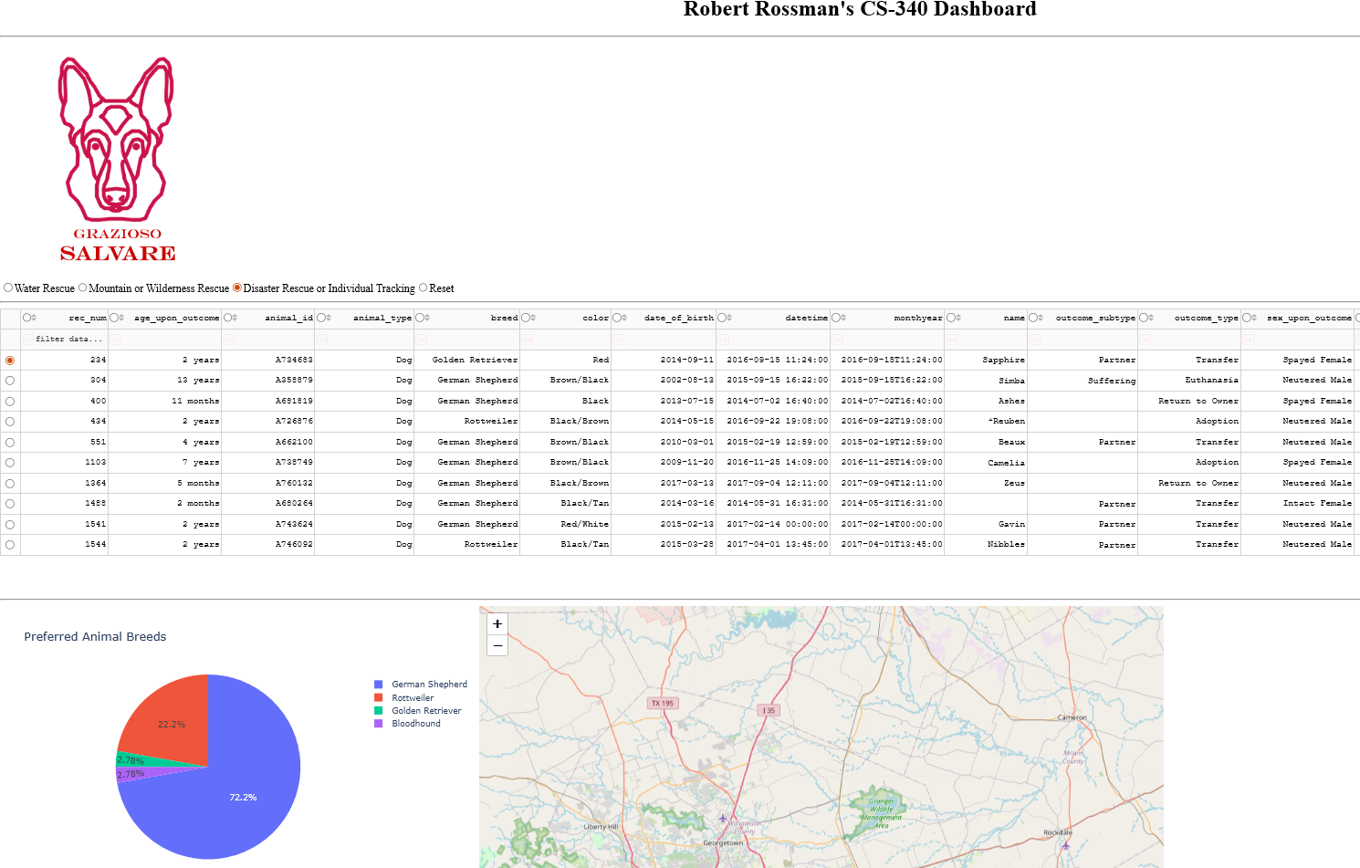
“Reset” data filter applied: 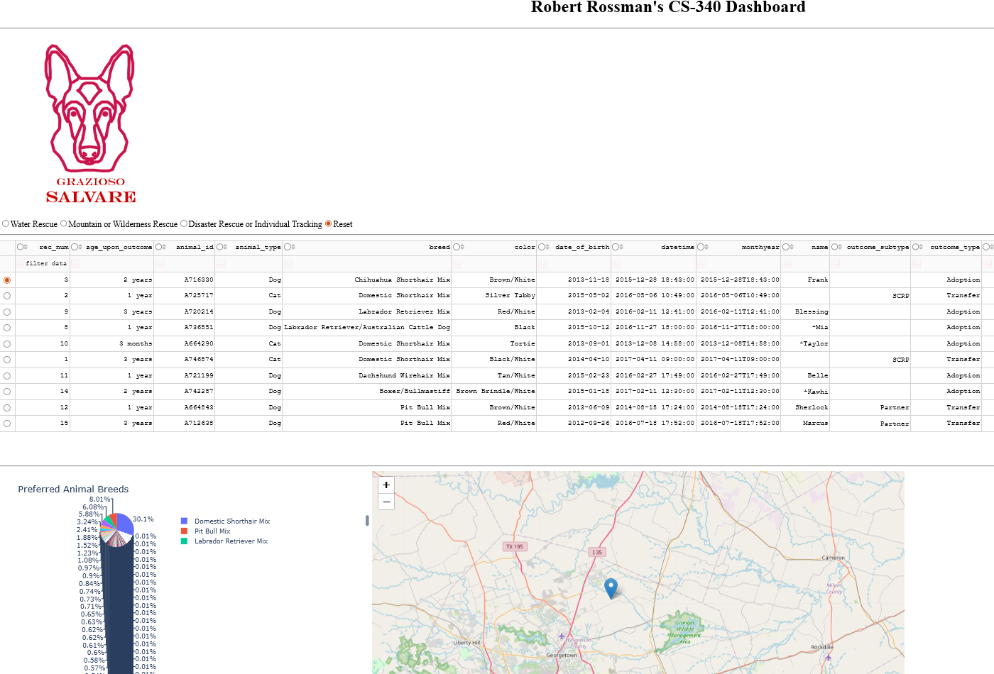

Steps Taken
To complete this project, I first imported a previously written CRUD python module that allowed me to connect to the animal shelter database and read and filter its entries. From there, I built the layout of the app, including a unique identifier, the Grazioso Salvare logo with a URL anchor tag, and a DataTable with selectable columns and rows.
Importantly, I also added radio buttons corresponding to “Water Rescue,” “Mountain or Wilderness Rescue,” “Disaster Rescue or Individual Tracking,” and “Reset” data filters. I made it so that selecting these radio buttons uses a callback to change the filter currently being used which then updates the dashboard accordingly. A pie chart is also displayed which uses callbacks to update the breeds of the animals it shows according to the current filter. Lastly, a map is displayed which uses callbacks to update which animal it displays the location of based on which animal is currently selected in the DataTable.
Challenges
Most of my challenges in this project came from trying to get the update_dashboard callback to work. Aside from initially having some syntax errors, my major problem came from me neglecting to include the function df.drop(columns=['_id'], inplace=True)to clean up the Mongo _id field.
I also had some difficulty with displaying the Grazioso Salvare logo but found that I simply needed to add the code to display the image into the app.layout. After discovering this, it was trivial to add the URL anchor using href and even to scale down the image using width and height.

Contact
Robert Rossman

